State diagram for class “Account”

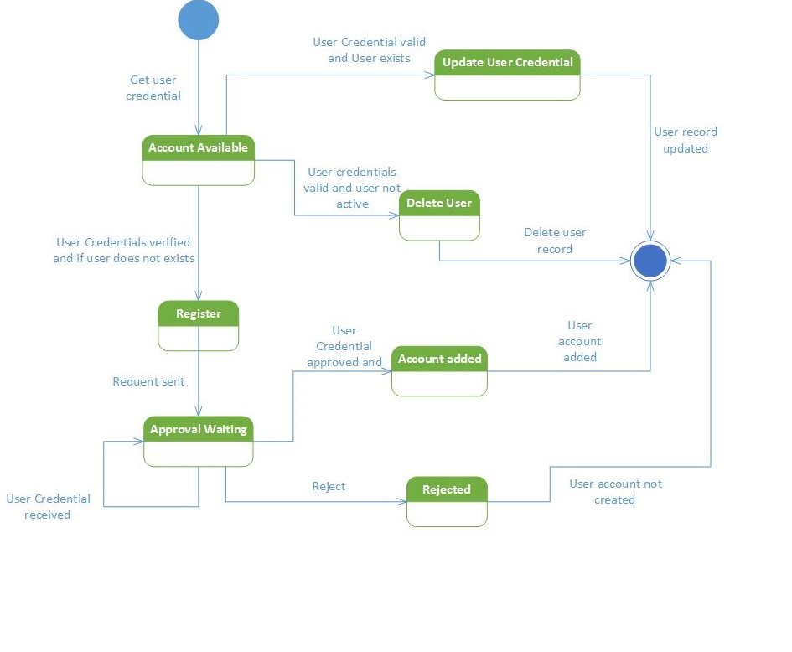

Explaination:

System will be in *Account Available* state initially. *The Account Available* has three scenarios:

Scenario 1.a: - Update User Credential

This state is achieved if the user’s credentials are valid and if user exists, the system will allow user to update User Credential and then will reach to final termination.

Scenario 1.b: - Delete User

This state is achieved if the user credentials are valid and user is no more active or participating, the system will allow admin to delete the user’s record and thereby reach to final termination.

Scenario 1.c: - Register

This state is achieved after performing the action of verifying user credential and if user’s account does not exists, the system will instantly move to the *Register state*. In the Register state, the user will enter the User profile credentials to register the account in the system and till any further action is taken the system will remain in the *Approval Waiting state*. The *Approval Waiting state* gives rise to two scenarios:

***Scenario 2.a***: *Account Added* state

After reaching the *Approval Waiting state*, a condition will be checked to determine whether the user’s credential entered are correct. If the condition is true then the system add the account and will thereby leading to *Termination* state.

***Scenario 3:*** *Rejected* state

This state will be achieved if the user’s credentials entered are invalid and thereby leading to state of *Termination* .

***Scenario 4:***